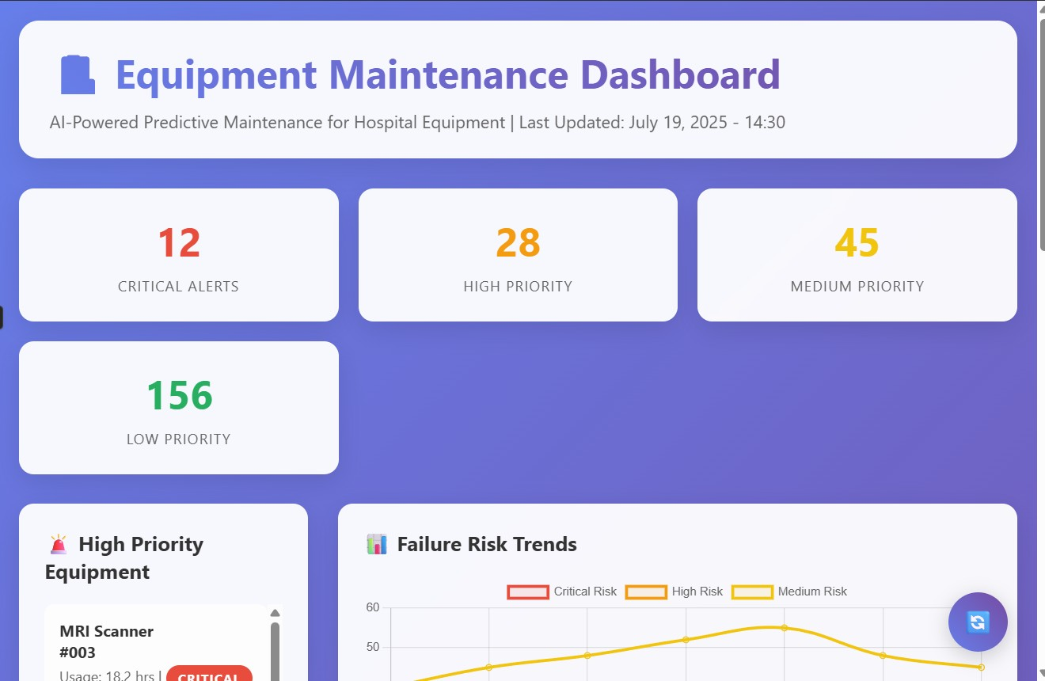

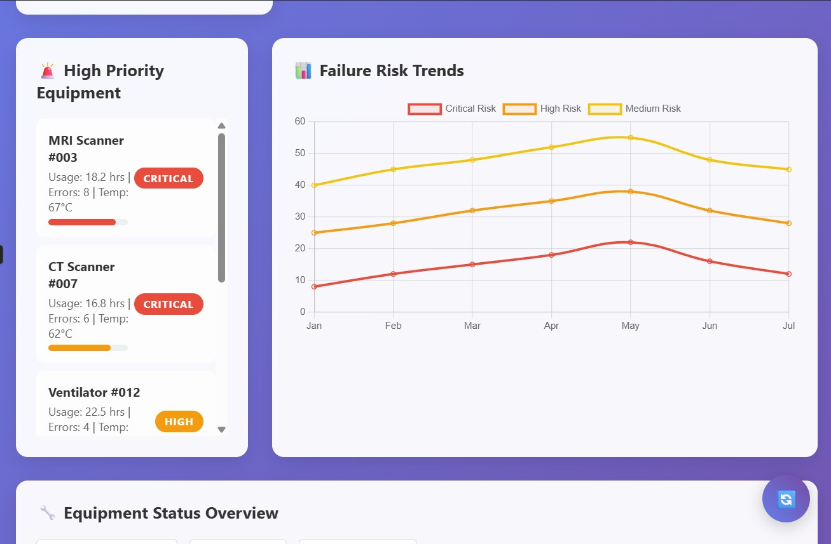

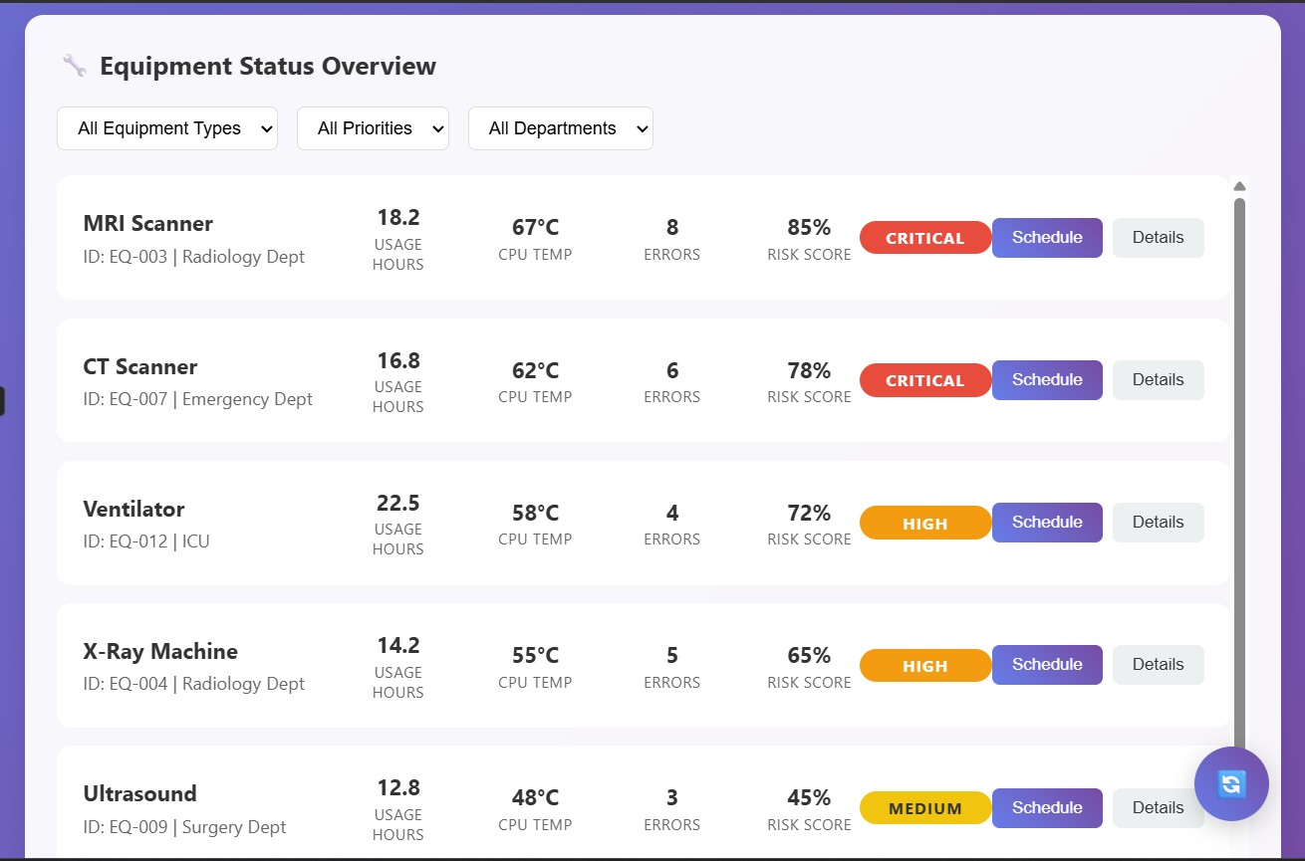

how I want my ui to look:

home page with basic details with a login button

on clicking the login button, a page or pop up to enter credentials (username and password), on entering the username it should show the role that username has (biomedical engineer or admin or technician)

based on the role the ui differs (already handled in FastAPI through role based access)

biomedical engineer/nurse who monitors the equipment:

should see a list of all the equipment with basic details like equipment id, type, location, status (health of the equipment ie if it needs maintenance or not with green or red visuals)

on clicking the equipment id or name, it needs to open a different page showcasing the trends graph, metrics of the equipment, if it has any maintenance logs, and the llm explanation based on the role, and a schedule maintenance button which when clicked opens a calendar to schedule the maintenance for that equipment. On scheduling the maintenance the logs must be added to the maintenance_log table with the details

above the list of equipments there should be a filter to sort based on maintenance_needs or not, filter based on location, equipment type, etc such more filters to make it easier to navigate and see their metrics, graphs and gathers info

Admin role:

should see eda graphs ie visualization graphs based on all the equipments in the hospital like a dashboard which should change as and when new equipments or logs or any info is added i.e, it should be dynamic

this dashboard must be on top

below that it should have a list of all the equipment with basic details like equipment id, type, location, status (health of the equipment ie if it needs maintenance or not with green or red visuals)

on clicking the equipment id or name, it needs to open a different page showcasing the trends graph, metrics of the equipment, if it has any maintenance logs, and the llm explanation based on the role, and a schedule maintenance button which when clicked opens a calendar to schedule the maintenance for that equipment. On scheduling the maintenance the logs must be added to the maintenance_log table with the details

above the list of equipmnts and below the dashboard, there should be a filter to sort based on maintenance_needs or not, filter based on location, equipment type, etc such more filters to make it easier to navigate and see their metrics, graphs and gathers info

technician:

should see the list of equipments only which are scheduled for maintenance with basic details like equipment id, type, location, status (health of the equipment ie if it needs maintenance or not with green or red visuals)

on clicking the equipment id or name, it needs to open a different page showcasing the trends graph, metrics of the equipment, if it has any maintenance logs, and the llm explanation based on the role

Unique UI/UX Enhancements (Optional but Valuable)

1. Predictive Alerts (Banner or Toast)

Show banner alerts like:

"3 MRI scanners may fail in next 7 days"

"ICU ventilator has high corrective maintenance risk"

🛠 Source: Use your failure prediction model or label thresholds.

2. Smart Filters Panel

On the Biomedical/Admin dashboard:

Add filter chips like Gmail:

[CT Scan], [Needs Maintenance], [ICU], [>5 yrs old] – dynamically added.

3. Color-coded Risk Badges

Instead of just red/green:

✅ Green = Healthy

🟡 Yellow = Medium Priority

🔴 Red = High Priority

Tie this to your maintenance_needs classification.

4. LLM Chat Assistant Panel (Sidebar)

Add a chat-style floating assistant that can answer:

"Show all CT machines needing replacement"

"Why does EQP007 need maintenance?"

This uses your /llm-explain endpoint.

5. Role Switcher (Admin Only)

If user is admin, allow switching to “view as technician/biomedical” — to preview what others see.

1. Alert Pop-Ups (Smart Notifications)

🔹 Triggered When:

Equipment is marked high risk for any maintenance type

Equipment is overdue for scheduled maintenance

An equipment's status is changed (e.g., "Completed")

🔹 Where to Show:

On dashboard load (top banner or modal)

Optional filter: View all alerts in a dropdown or notification center

2. Downloadable Reports (PDF/CSV)

🔹 For Individual Equipment (All roles)

Equipment info

Maintenance history

Trend graph snapshot

Prediction and LLM explanation

🔹 For All Equipment (Admin only)

Combined analytics with:

Pie charts (types, status)

Bar charts (downtime, failures)

Prediction summary

List of high-risk equipment

Audit Trail

log status changes, who changed it, and when. This helps with accountability.